**Milestone 1: Project Proposal and High-level description**

CEN 4010 Principles of Software Engineering, Fall 2019

Group 17

*Kyle Barrows- barrowsk2016@fau.edu*

*Brayan Villier- bvillier2017@fau.edu*

09/23/2019

***Project : Campus Snapshot***

**History Table:**

|  |  |
| --- | --- |
| **Date** | **Revisions** |
| **09/23** | **Original Submission** |
|  |  |

**Executive Summary**

A web system names Campus Snapshot will be developed to ease reporting of issues in university campus. Life events such as games, outdoor concerts, and students activities will also be included in this software. The need to report issues such as broken lamps, road hazards, etc is very important for the University for smooth operation. This software application will be designed to make reporting by anyone in University very easy and to provide a real time snapshot to University administrators.

**Competitive Analysis**

We couldn’t find any competitors with targeting towards universities, however we think the most similar kind of software out there would be Waze featuring live, user-reported issue tracking for highways and roads.Key benefits for end user of this product are the instant reporting from a click of a button, administrator's monitoring, reporting of incidents to appropriate campus personnel, and reporting of creational events or student activities. Hence, this product will allow a smooth operation for the university campus.

**Data Definition**

A reported issue will have a location, timestamp, and a brief description of what the problem is. Users (students and staff) will be able to view all current issues.

**Overview and Use Cases**

This application is intended to be used by university students and faculty. This app will enable its users to report or view issues and their locations such as clogged toilets or debris in walkways and will let the university quickly know where it has occured to get it fixed quickly. Mainly, the users would access the main options in the website application (Fig1) and would be able to provide a description of the situation and upload documents or pictures. For example, by clicking on “report broken items” on Campus Snapshots, Next page (Fig2) would provide the users the ability to upload pictures and report the events. The figures below are just prototype or preliminary view of the application that will be built. Background will be filled with more pictures to make it more attractive for users.

*Fig1.- Preliminary view (prototype) of Campus Snapshots*

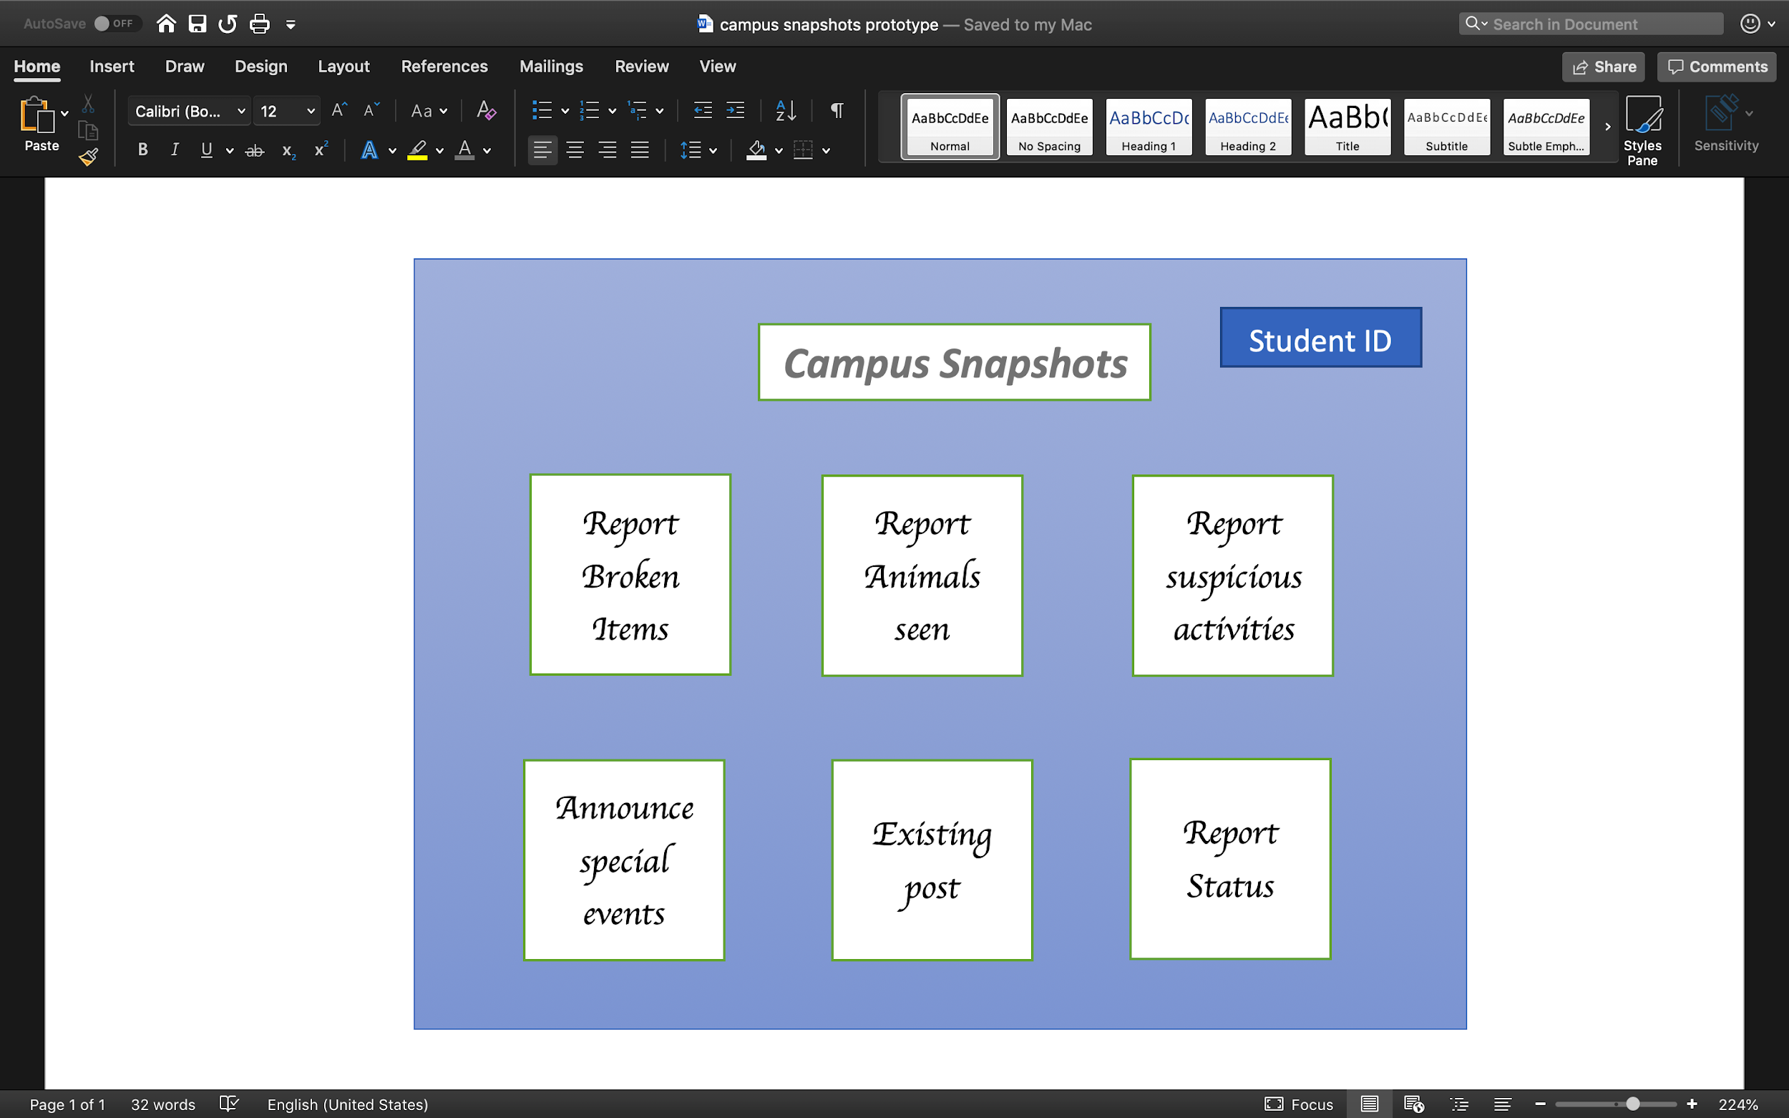

*Fig2.- Preliminary view of next page when clicking on “Report Broken Items”*

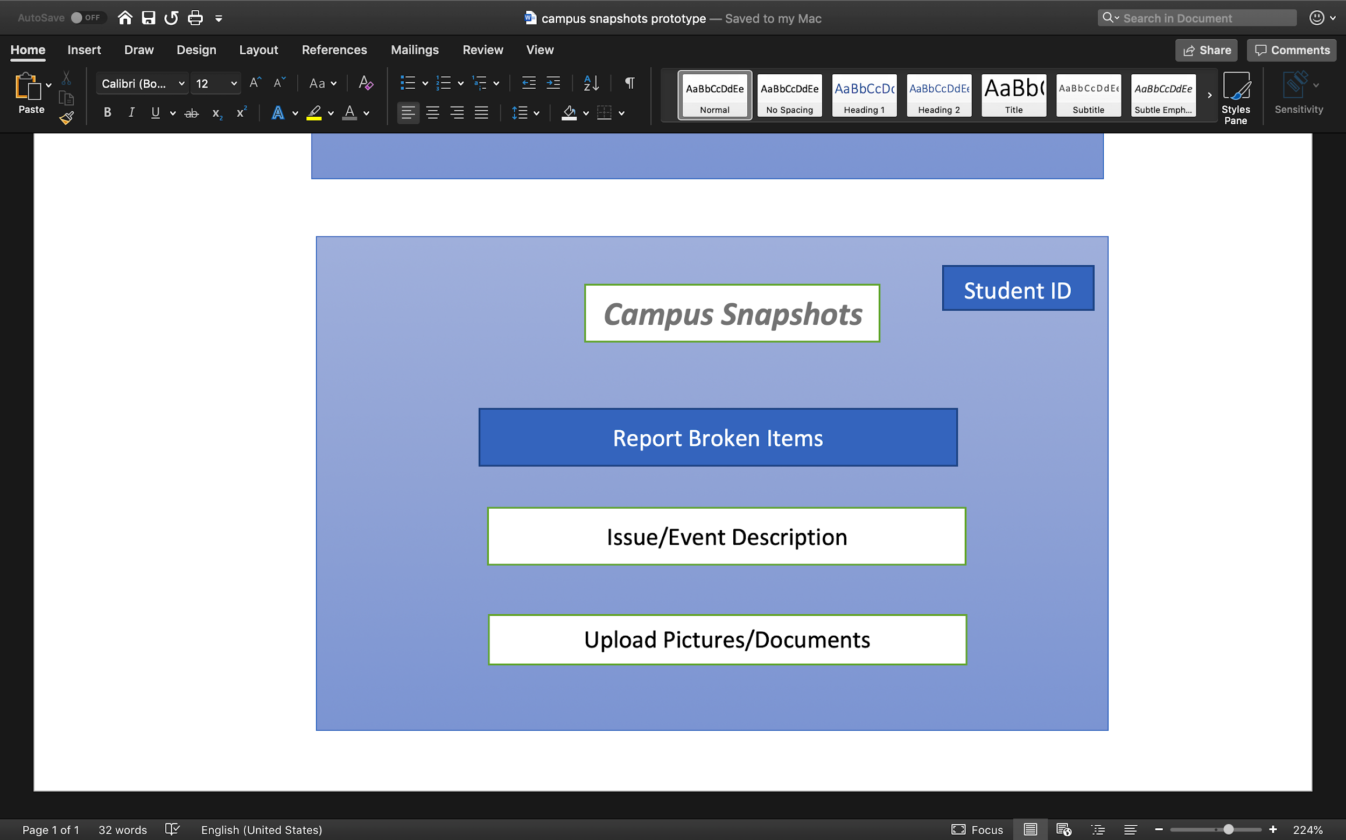

**Functional Requirements**

This software will be designed with Agile development style. For instance, function requirements will be heavily implemented by designing one module at a time. Other functional requirements, presenting in modules, would have the same format. That would make the software very easy to use.

1. User should have the ability to report issues on the university such as non functioning items or animals at locations that are within the university's perimeter.
2. Other users can view details about current issues reported by others and acknowledge them.
3. Campus staff will be able to view all current issues and update their status such as “resolved” or “unresolved”.
   1. Campus staff can provide an estimated time of when an issue will be resolved.

**Non-functional Requirements**

Non-functional requirements website speed performance and security, expected loads, storage, availability will be taken into consideration. Third party tools such as GT metrix to measure the speed, load capacity of the website will be taken into consideration.

1. Any first time user should be able to report an issue or view current ones.
2. Only students or staff of the university should be able to report or view issues.

**System-Architecture**

Java will be the main tool to build Campus Snapshot website. Java API will be mostly exploited to create a powerful website for the users to use. Since Google Chrome is one of the most used websites, it will be used as our supported browser. Other options will also be considered. GWT (Google Web Tool) kit or JSF (JavaServer Faces) would be used as Web Frameworks.

**Team**

Roles TBD

Kyle Barrows:   
Brayan Villier: